Day 32 (12 September 2025)
112552596 - vsisukhw - Sukhwinder Singh

For tasks questions , refer
https://docs.google.com/document/d/1HCE8PeM6mlChMoy58hkkPs0erpOmIOESgw1u747tKrg/edit?tab=t.0

Task 1
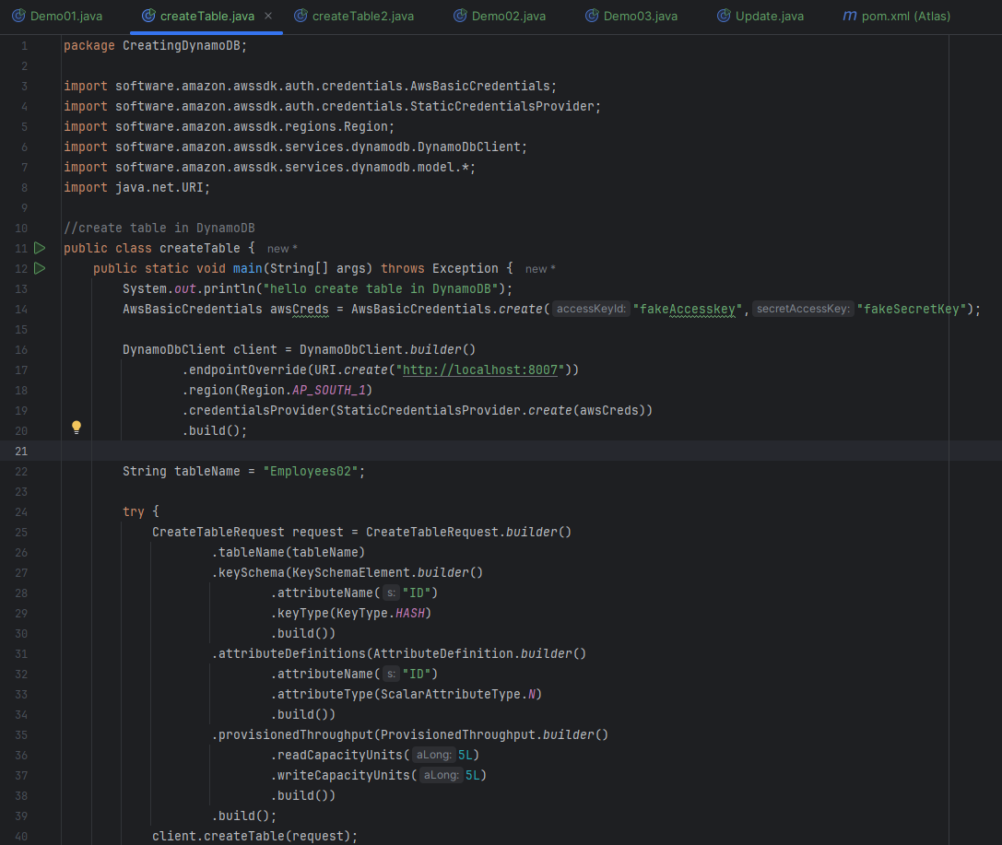
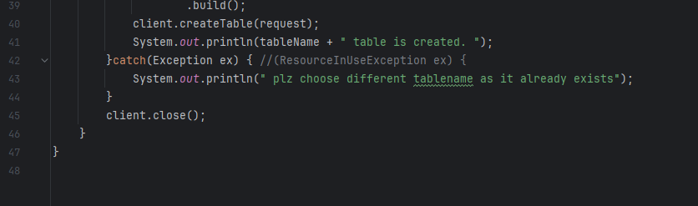

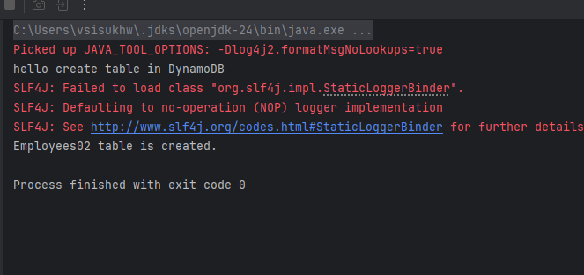
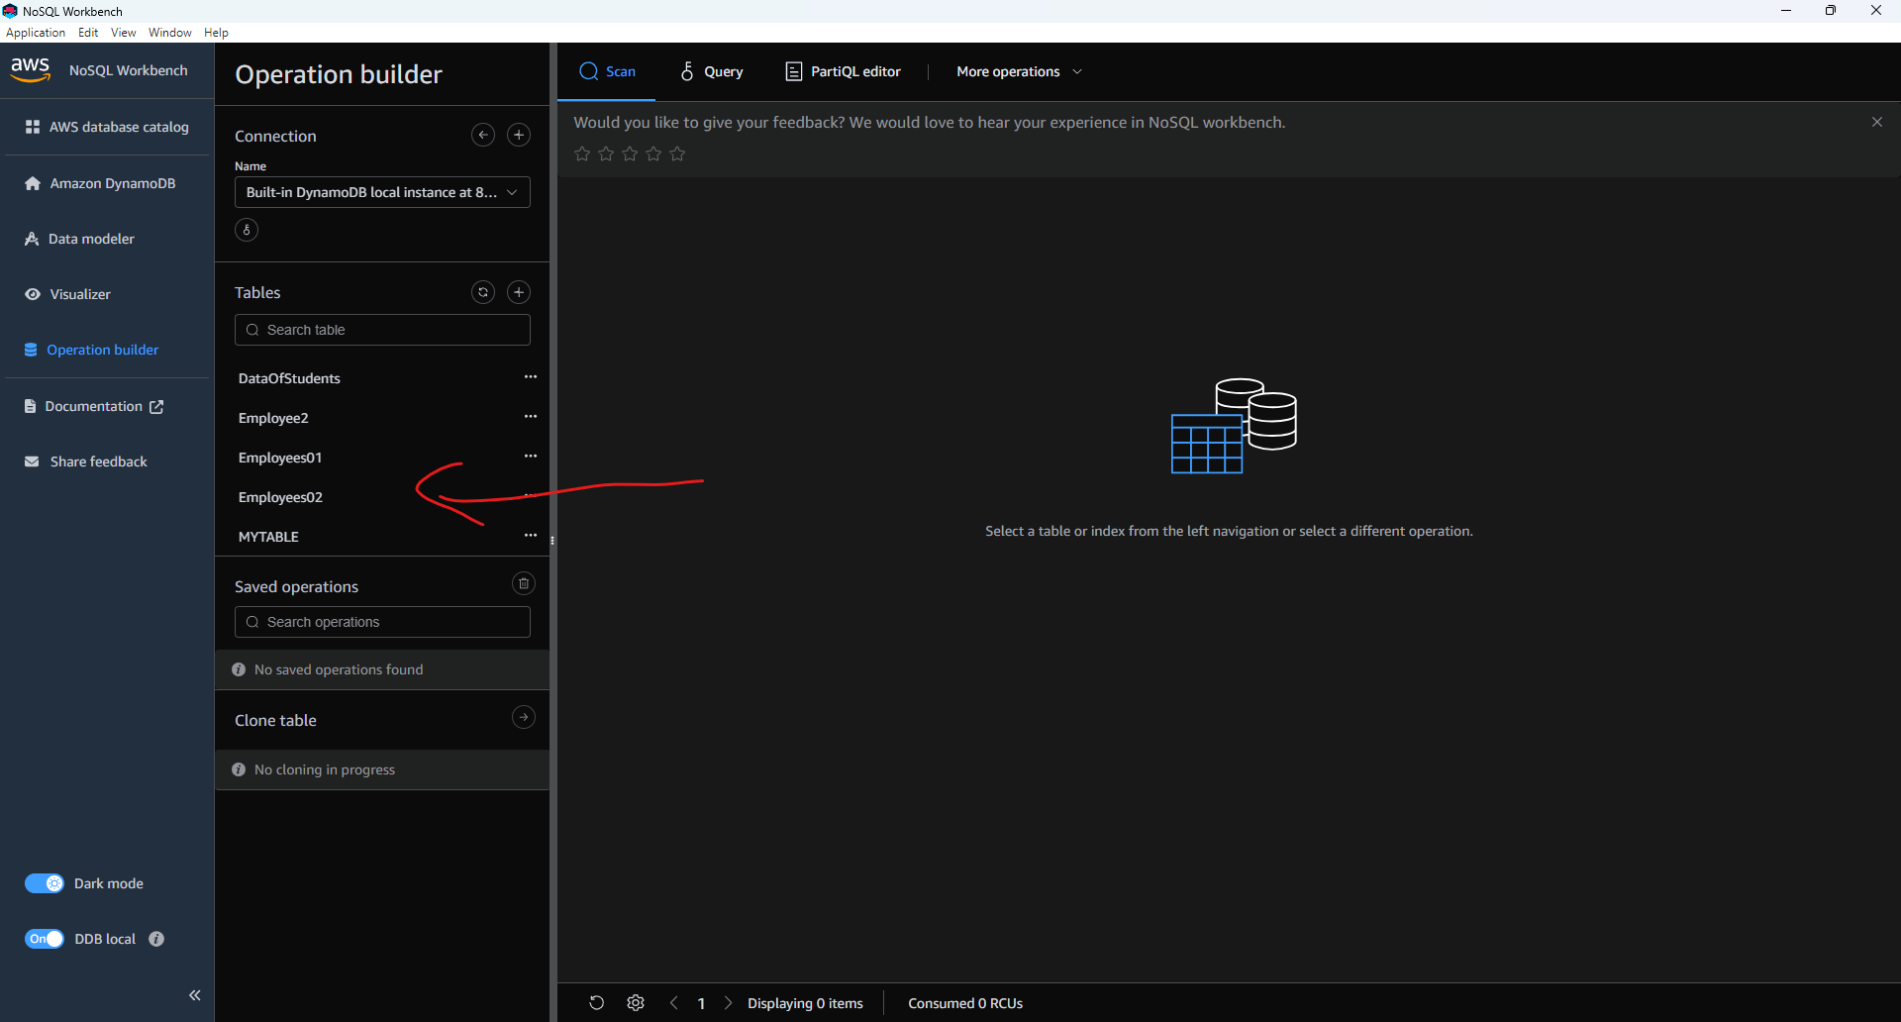

Task 2

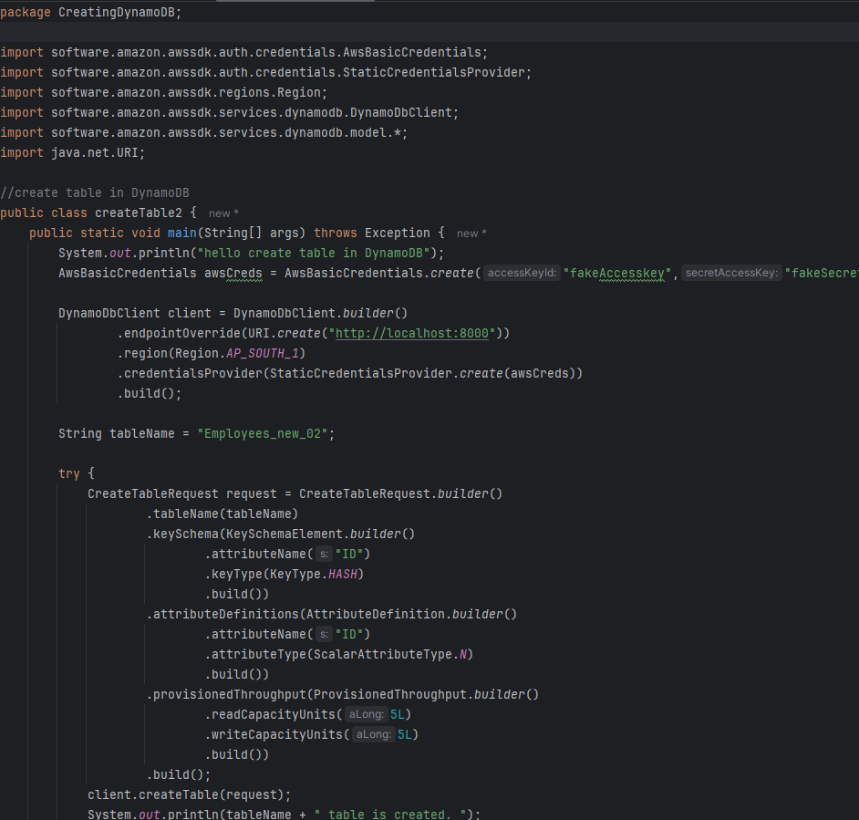
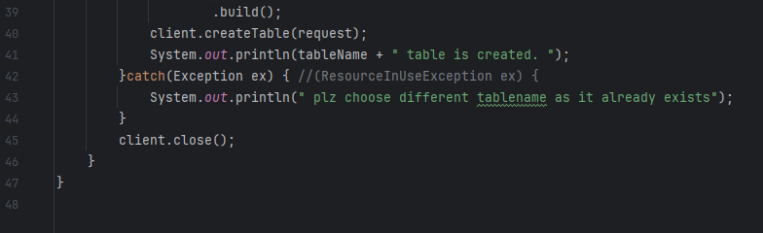
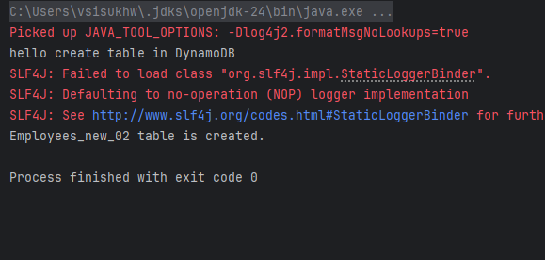
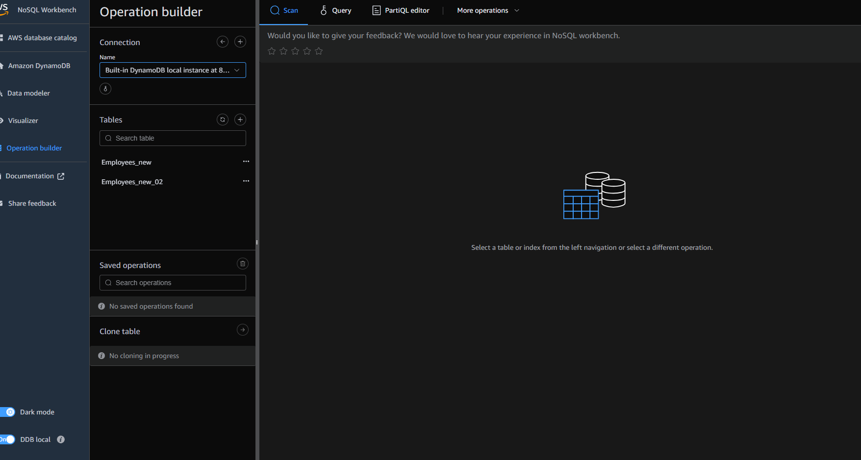
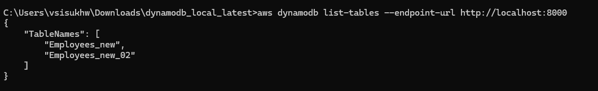

Task 3
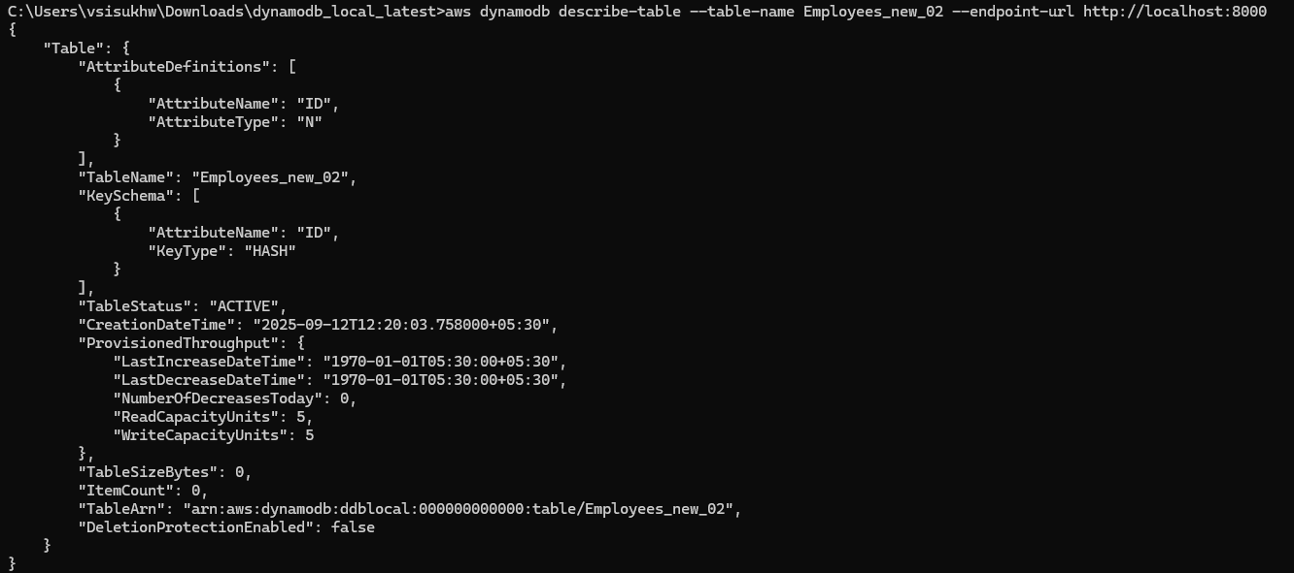

Task 4
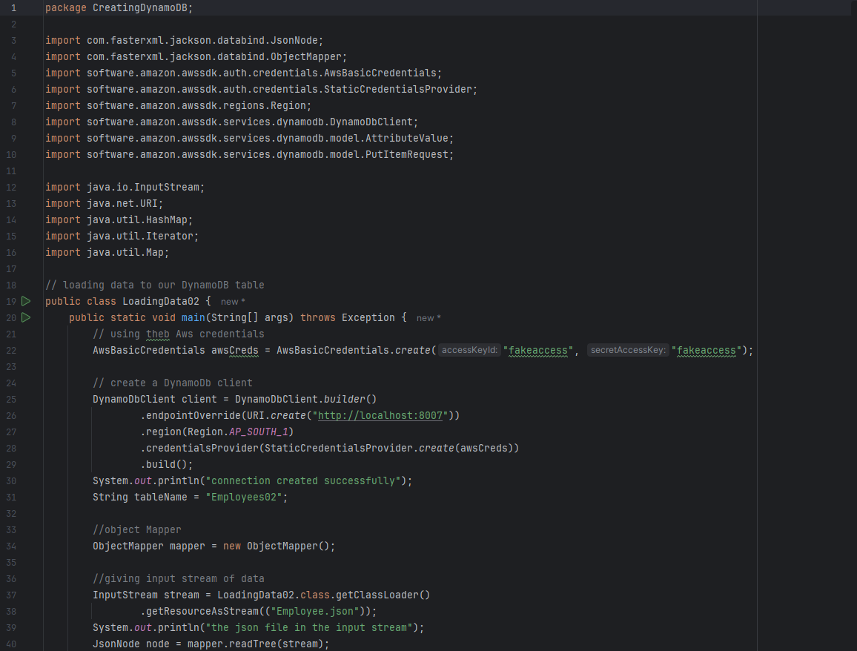
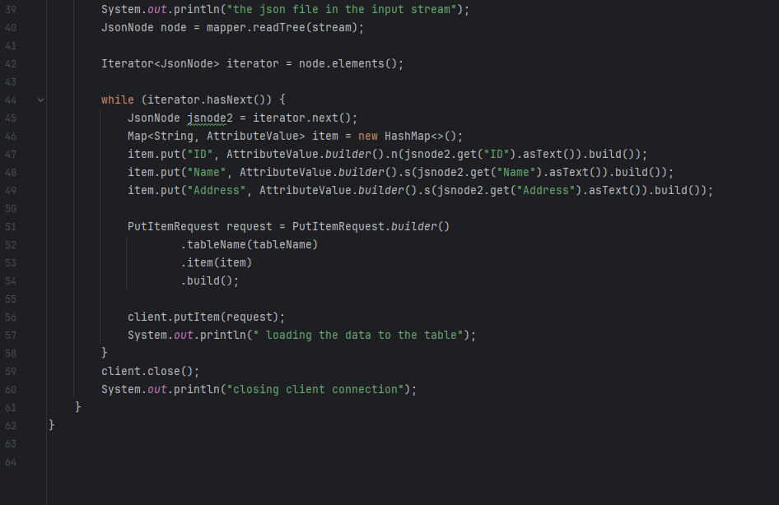
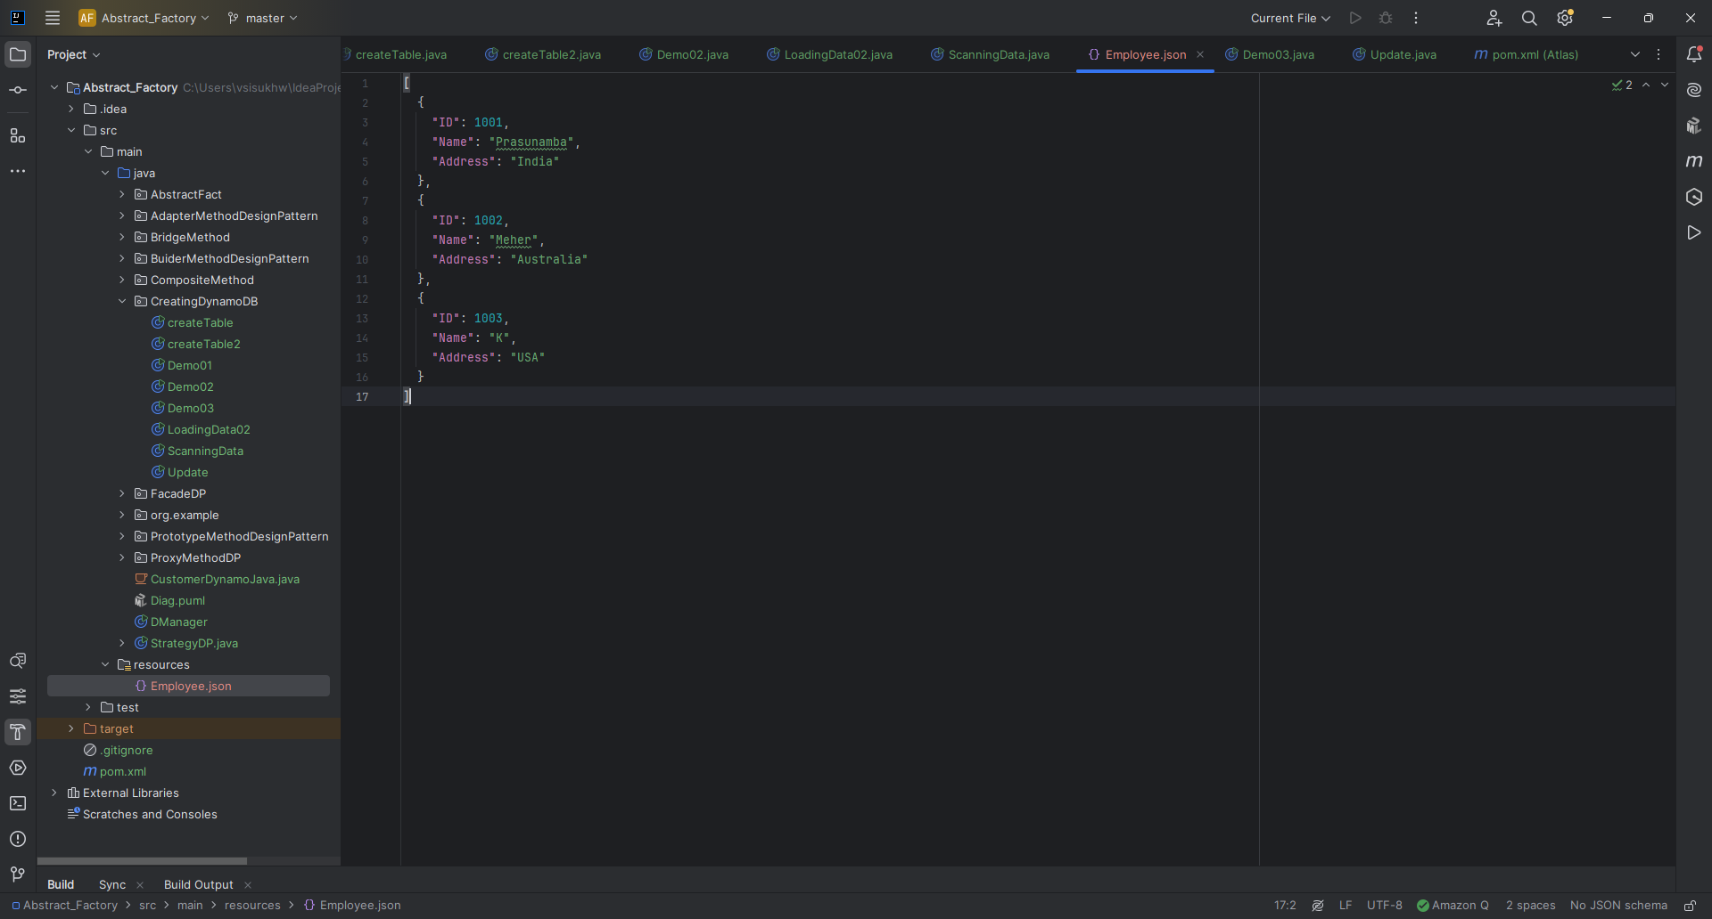
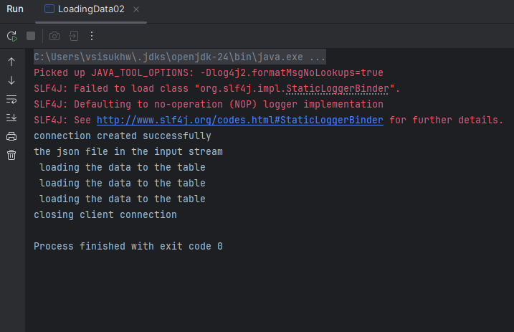
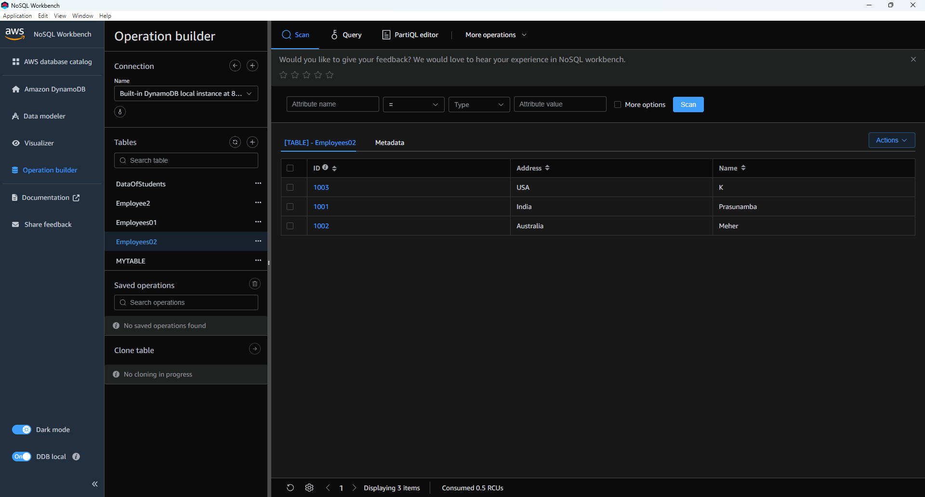
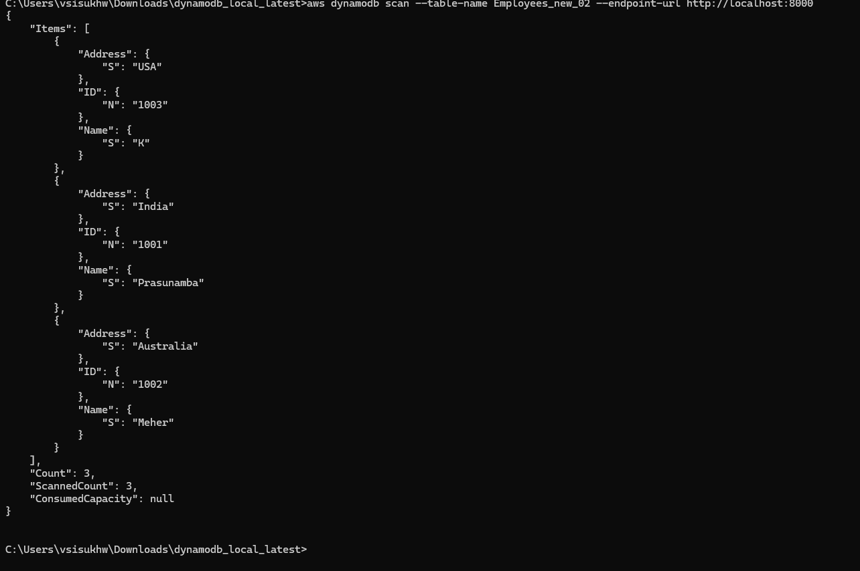

Task 5
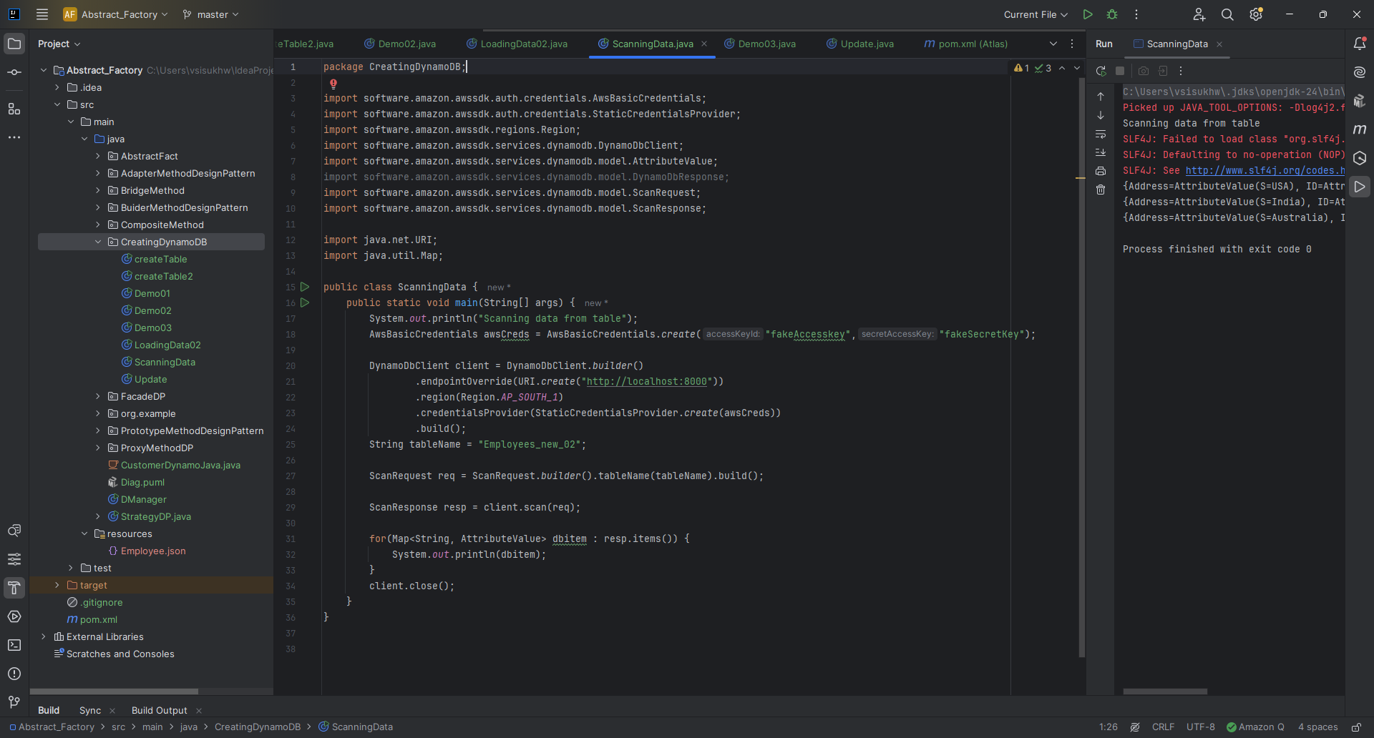
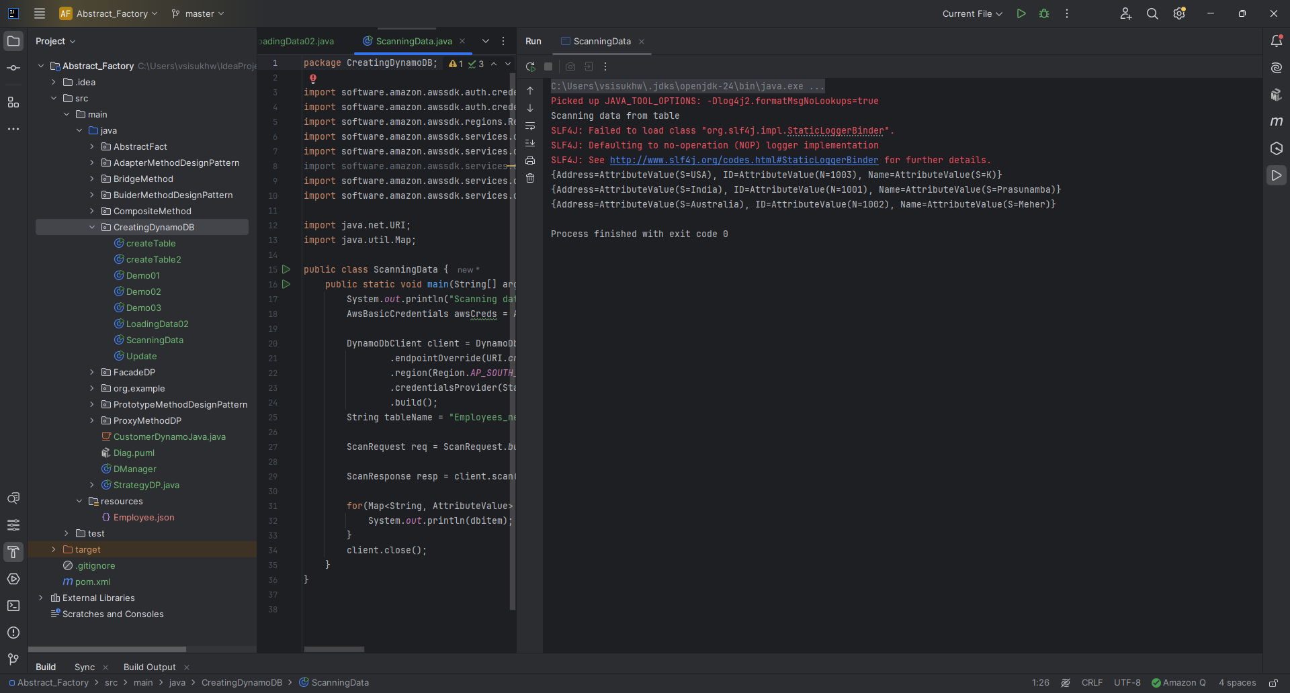

Task 6
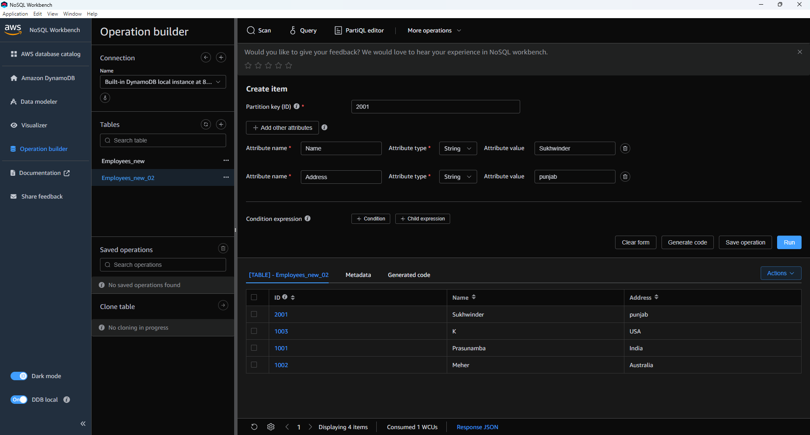
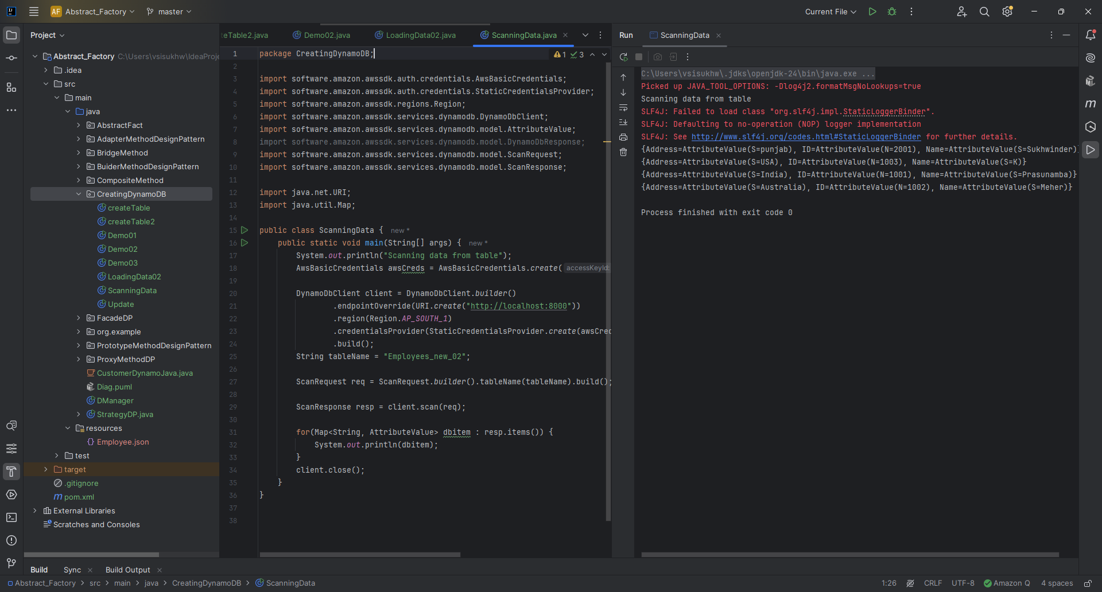

Task 7
How do you lower the cost of DynomaDB..explain ways to do so

- Pick the right capacity mode –
Use On-Demand for unpredictable traffic, Provisioned + Auto Scaling for steady workloads.
- Cache reads –
Use DAX or Redis to reduce repeated read costs.
- Optimize queries –
Avoid Scan, use Query by keys, batch operations where possible.
- Use TTL –
Auto-delete old/unused items to save storage.
- Right-size capacity –
Monitor CloudWatch, reduce over-provisioning.
- Minimize streams & replicas –
Only enable DynamoDB Streams and Global Tables if needed.
- Archive old data –
Move rarely accessed data to S3 instead of keeping it in DynamoDB.
In short: cache smartly, use the right capacity mode, clean up old data, and optimize queries = lower DynamoDB bills.

Task 8

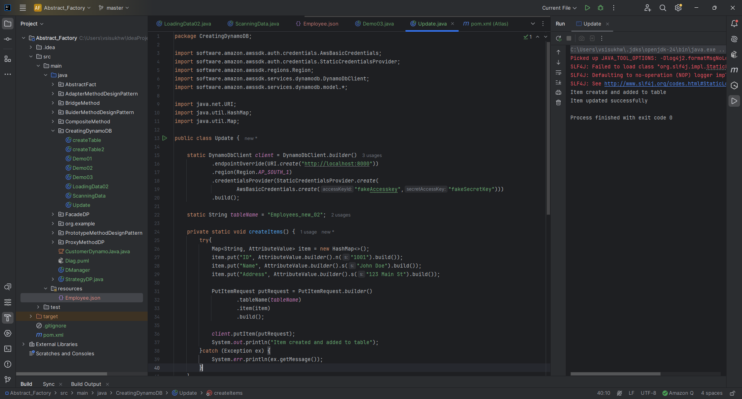
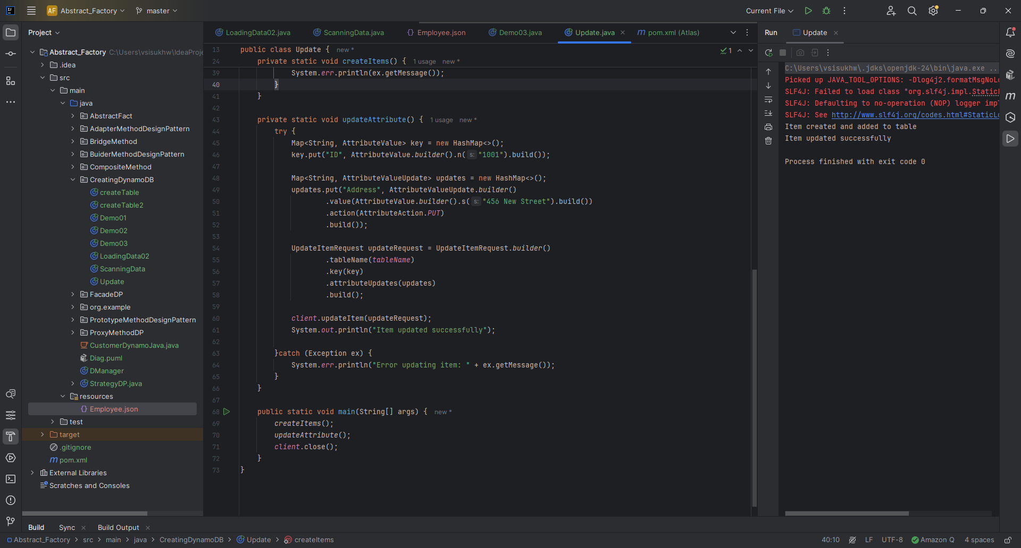
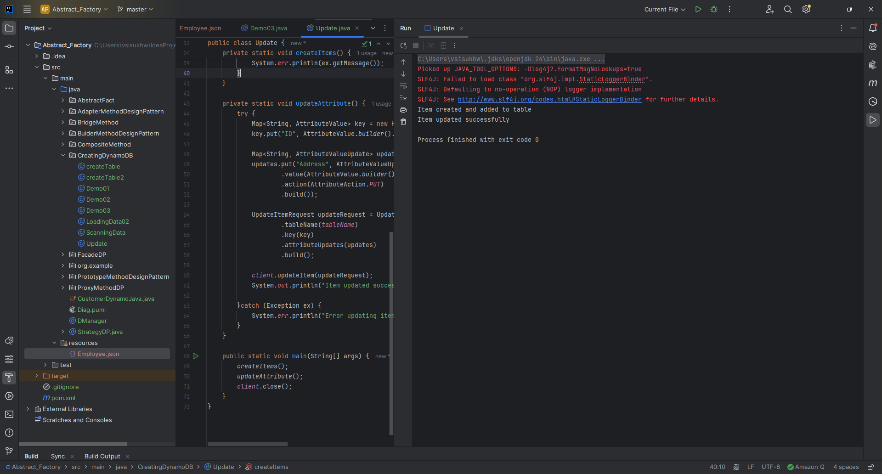
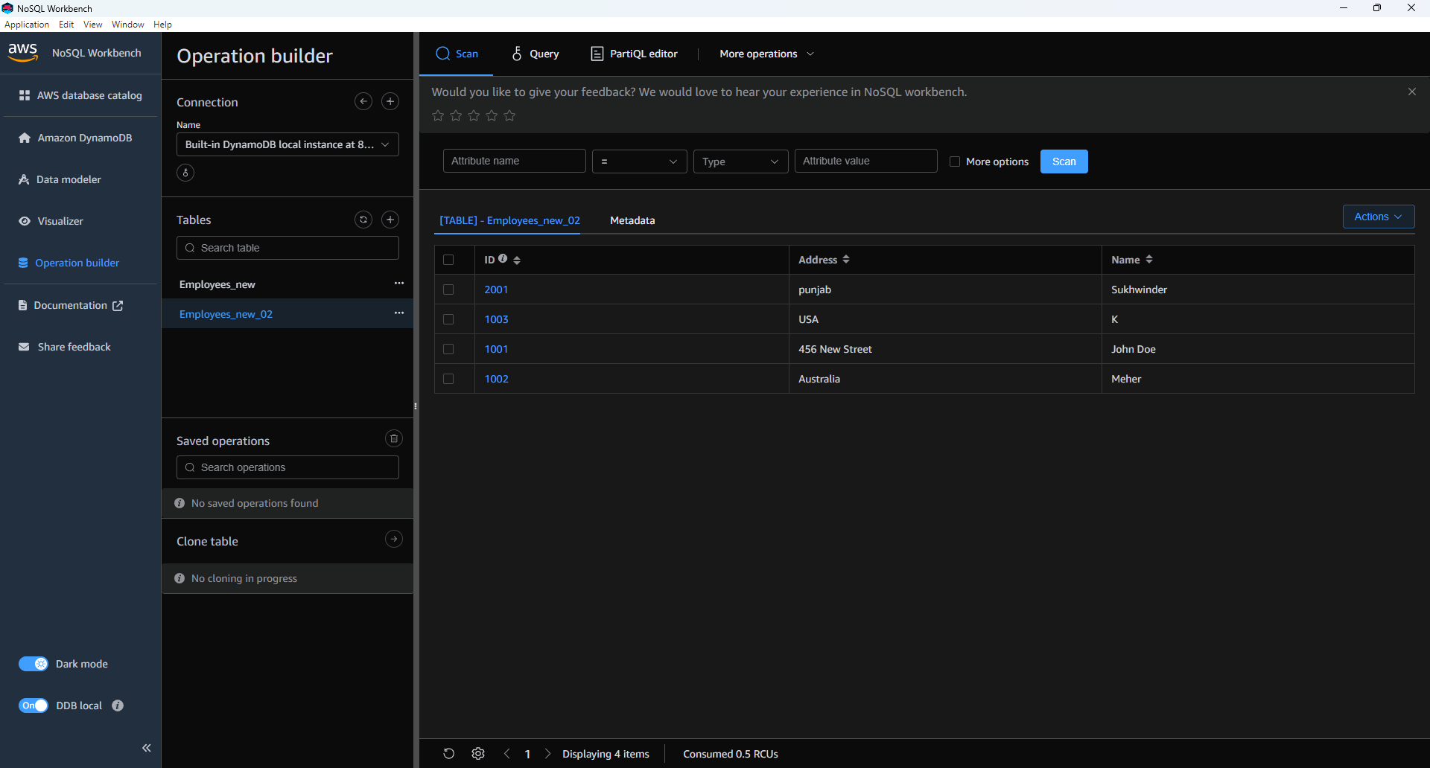

Task 9

Before deleting

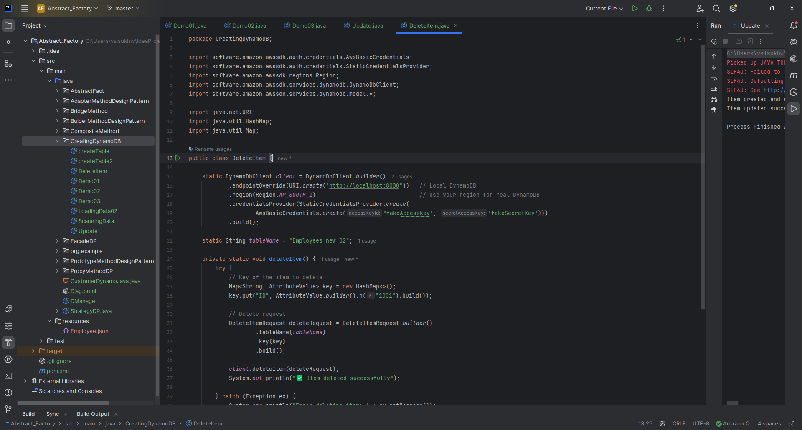
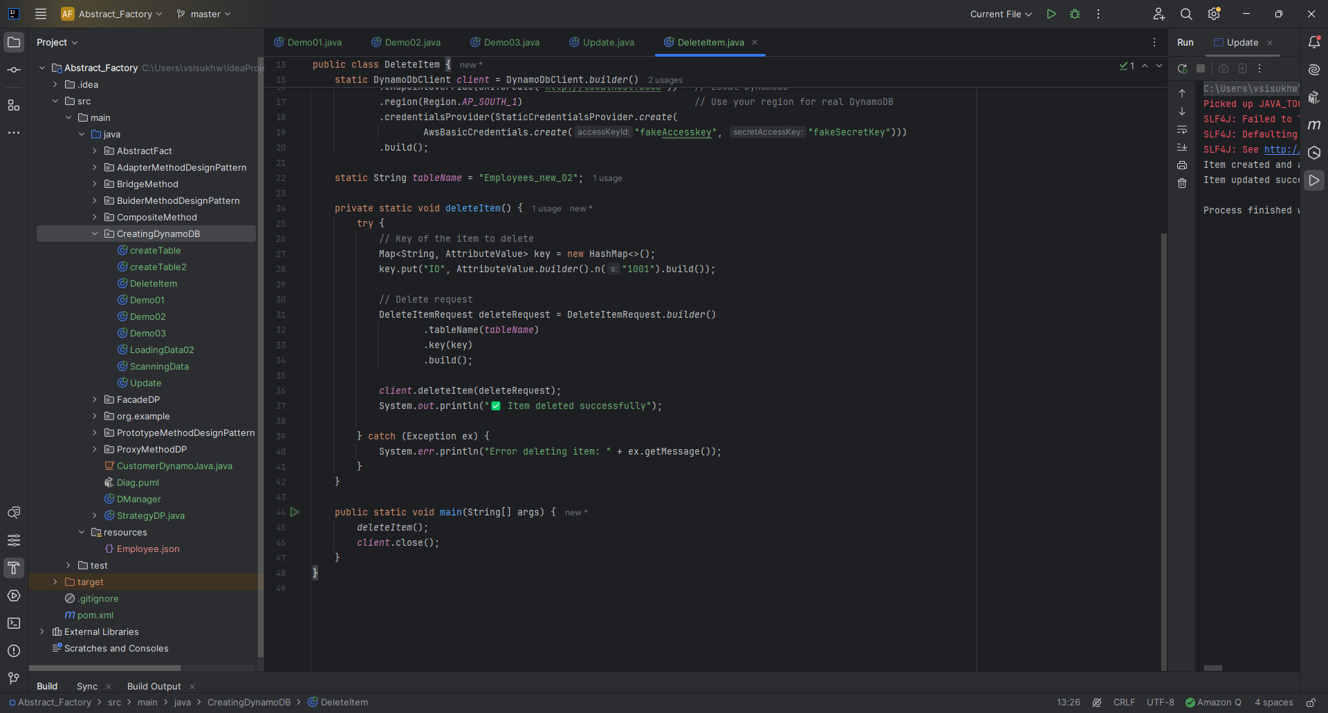
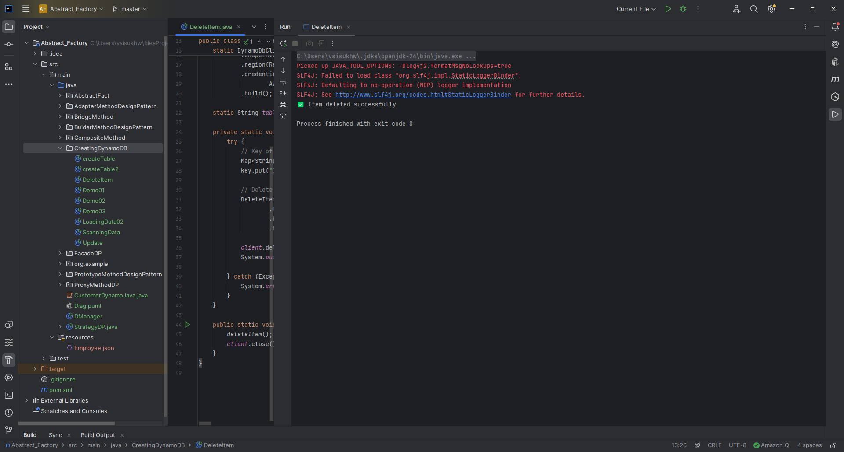

After Deleting
